[](https://www.google.co.uk/url?sa=i&url=https%3A%2F%2Fwww.schoolsinsight.co.uk%2Fschool%2Fstockport%2Fbanks-lane-junior-school&psig=AOvVaw3Un7SWsjBacaOkk1ZuqY0p&ust=1585254124675000&source=images&cd=vfe&ved=0CAIQjRxqFwoTCJjQs_y5tugCFQAAAAAdAAAAABAD)

**Banks Lane**

[](https://www.google.co.uk/url?sa=i&url=https%3A%2F%2Fwww.bankslane-jun.stockport.sch.uk%2F&psig=AOvVaw3Un7SWsjBacaOkk1ZuqY0p&ust=1585254124675000&source=images&cd=vfe&ved=0CAIQjRxqFwoTCJjQs_y5tugCFQAAAAAdAAAAABAK)**10x10x10**

**Challenge**

[](https://www.google.co.uk/url?sa=i&url=https%3A%2F%2Ffineartamerica.com%2Fshop%2Fposters%2Faerobic%2Bexercise&psig=AOvVaw1H1K0mnP7aL6MI8c6H3NA-&ust=1585254254306000&source=images&cd=vfe&ved=0CAIQjRxqFwoTCPCQ-dO6tugCFQAAAAAdAAAAABAE)

10 exercises

10 times

10 days

Children of Banks Lane. You have been challenged!

Complete your 10 exercises, 10 times over the next 10 days to receive your first 10x10x10 certificate.

Every 10 days you will receive a new challenge.

[](https://www.google.co.uk/url?sa=i&url=https%3A%2F%2Ffineartamerica.com%2Fshop%2Fposters%2Faerobic%2Bexercise&psig=AOvVaw1H1K0mnP7aL6MI8c6H3NA-&ust=1585254254306000&source=images&cd=vfe&ved=0CAIQjRxqFwoTCPCQ-dO6tugCFQAAAAAdAAAAABAE)

**10x10x10**

**Tick**

**List**

**Day 10**

* **10 Star jumps**
* **10 Touch your toes**
* **10 Weightlifting**
* **10 Step ups**
* **10 Burpees**
* **10 High knees**
* **10 Sit ups**
* **10 Squats**
* **10 Lunges**
* **10 skips**

**Day 8**

* **10 Star jumps**
* **10 Touch your toes**
* **10 Weightlifting**
* **10 Step ups**
* **10 Burpees**
* **10 High knees**
* **10 Sit ups**
* **10 Squats**
* **10 Lunges**
* **10 skips**

**Day 7**

* **10 Star jumps**
* **10 Touch your toes**
* **10 Weightlifting**
* **10 Step ups**
* **10 Burpees**
* **10 High knees**
* **10 Sit ups**
* **10 Squats**
* **10 Lunges**
* **10 skips**

**Day 9**

* **10 Star jumps**
* **10 Touch your toes**
* **10 Weightlifting**
* **10 Step ups**
* **10 Burpees**
* **10 High knees**
* **10 Sit ups**
* **10 Squats**
* **10 Lunges**
* **10 skips**

**Day 6**

* **10 Star jumps**
* **10 Touch your toes**
* **10 Weightlifting**
* **10 Step ups**
* **10 Burpees**
* **10 High knees**
* **10 Sit ups**
* **10 Squats**
* **10 Lunges**
* **10 skips**

**Day 5**

* **10 Star jumps**
* **10 Touch your toes**
* **10 Weightlifting**
* **10 Step ups**
* **10 Burpees**
* **10 High knees**
* **10 Sit ups**
* **10 Squats**
* **10 Lunges**
* **10 skips**

**Day 4**

* **10 Star jumps**
* **10 Touch your toes**
* **10 Weightlifting**
* **10 Step ups**
* **10 Burpees**
* **10 High knees**
* **10 Sit ups**
* **10 Squats**
* **10 Lunges**
* **10 skips**

**Day 3**

* **10 Star jumps**
* **10 Touch your toes**
* **10 Weightlifting**
* **10 Step ups**
* **10 Burpees**
* **10 High knees**
* **10 Sit ups**
* **10 Squats**
* **10 Lunges**
* **10 skips**

**Day 1**

* **10 Star jumps**
* **10 Touch your toes**
* **10 Weightlifting**
* **10 Step ups**
* **10 Burpees**
* **10 High knees**
* **10 Sit ups**
* **10 Squats**
* **10 Lunges**
* **10 skips**

**Day 2**

* **10 Star jumps**
* **10 Touch your toes**
* **10 Weightlifting**
* **10 Step ups**
* **10 Burpees**
* **10 High knees**
* **10 Sit ups**
* **10 Squats**
* **10 Lunges**
* **10 skips**

Exercise 1 – Star Jumps

[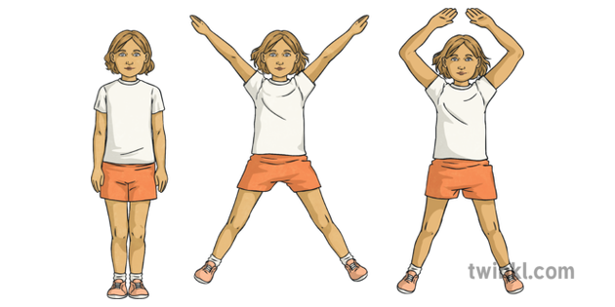](https://www.google.co.uk/url?sa=i&url=https%3A%2F%2Fwww.twinkl.co.uk%2Fillustration%2Fstar-jump-pe-gym-ks2&psig=AOvVaw1yR8ytcNOeHutB_4LfVTyj&ust=1585256540853000&source=images&cd=vfe&ved=0CAIQjRxqFwoTCMDqu__CtugCFQAAAAAdAAAAABAD)

Make sure your legs and arms are straight. Try to jump as high as you possibly can.

Exercise 2 – Touch your toes

[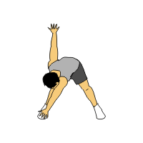](https://www.google.co.uk/url?sa=i&url=http%3A%2F%2Frebloggy.com%2Fpost%2Fa-simple-cardio-workout%2F17757653307&psig=AOvVaw3wjydFIk2s0KfC_TdgDGEc&ust=1585257124662000&source=images&cd=vfe&ved=0CAIQjRxqFwoTCJDe_J7FtugCFQAAAAAdAAAAABAg)

Make sure you stretch across your body so that your hand touches your opposite toe.

Exercise 3 – Weightlifting

[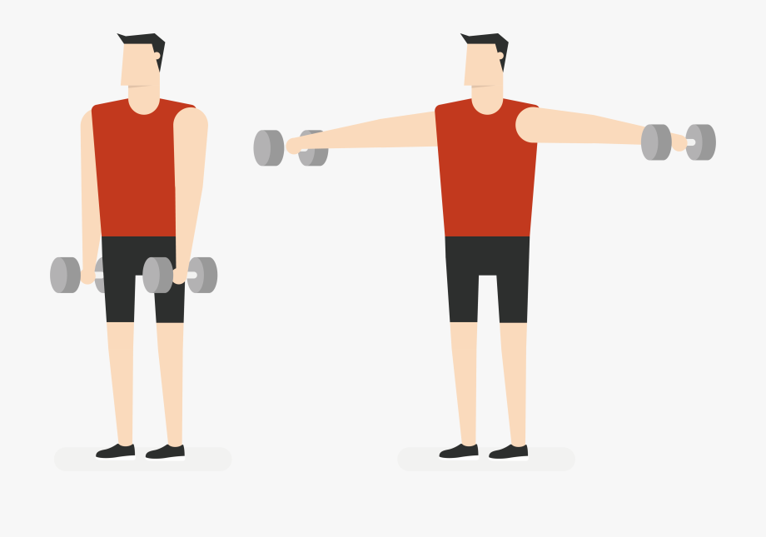](https://www.google.co.uk/url?sa=i&url=https%3A%2F%2Fwww.netclipart.com%2Fisee%2Fhoxxhw_physical-exercise-training-olympic-weightlifting-side-dumbbell%2F&psig=AOvVaw05QeX8PN8aReJ2b0w0UJLn&ust=1585257311352000&source=images&cd=vfe&ved=0CAIQjRxqFwoTCIDyhvLFtugCFQAAAAAdAAAAABAK)

Lift your weights and hold for 5 seconds.

Use cans of baked beans or similar.

Exercise 4 – Step ups

[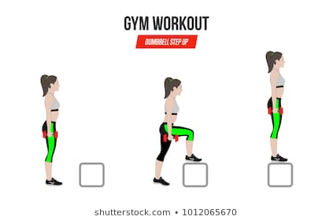](https://www.google.co.uk/url?sa=i&url=https%3A%2F%2Fwww.shutterstock.com%2Fsearch%2Fstep-up%2Bexercise%3Fimage_type%3Dvector%26search_source%3Dbase_related_searches%26language%3Den&psig=AOvVaw3mmxGkTk5KGpzYcztiskI8&ust=1585257487781000&source=images&cd=vfe&ved=0CAIQjRxqFwoTCPDO5L3GtugCFQAAAAAdAAAAABAS)

Use stairs or a box for your steps.

Slow steps work best. Don’t rush!

Exercise 5 – Burpees

[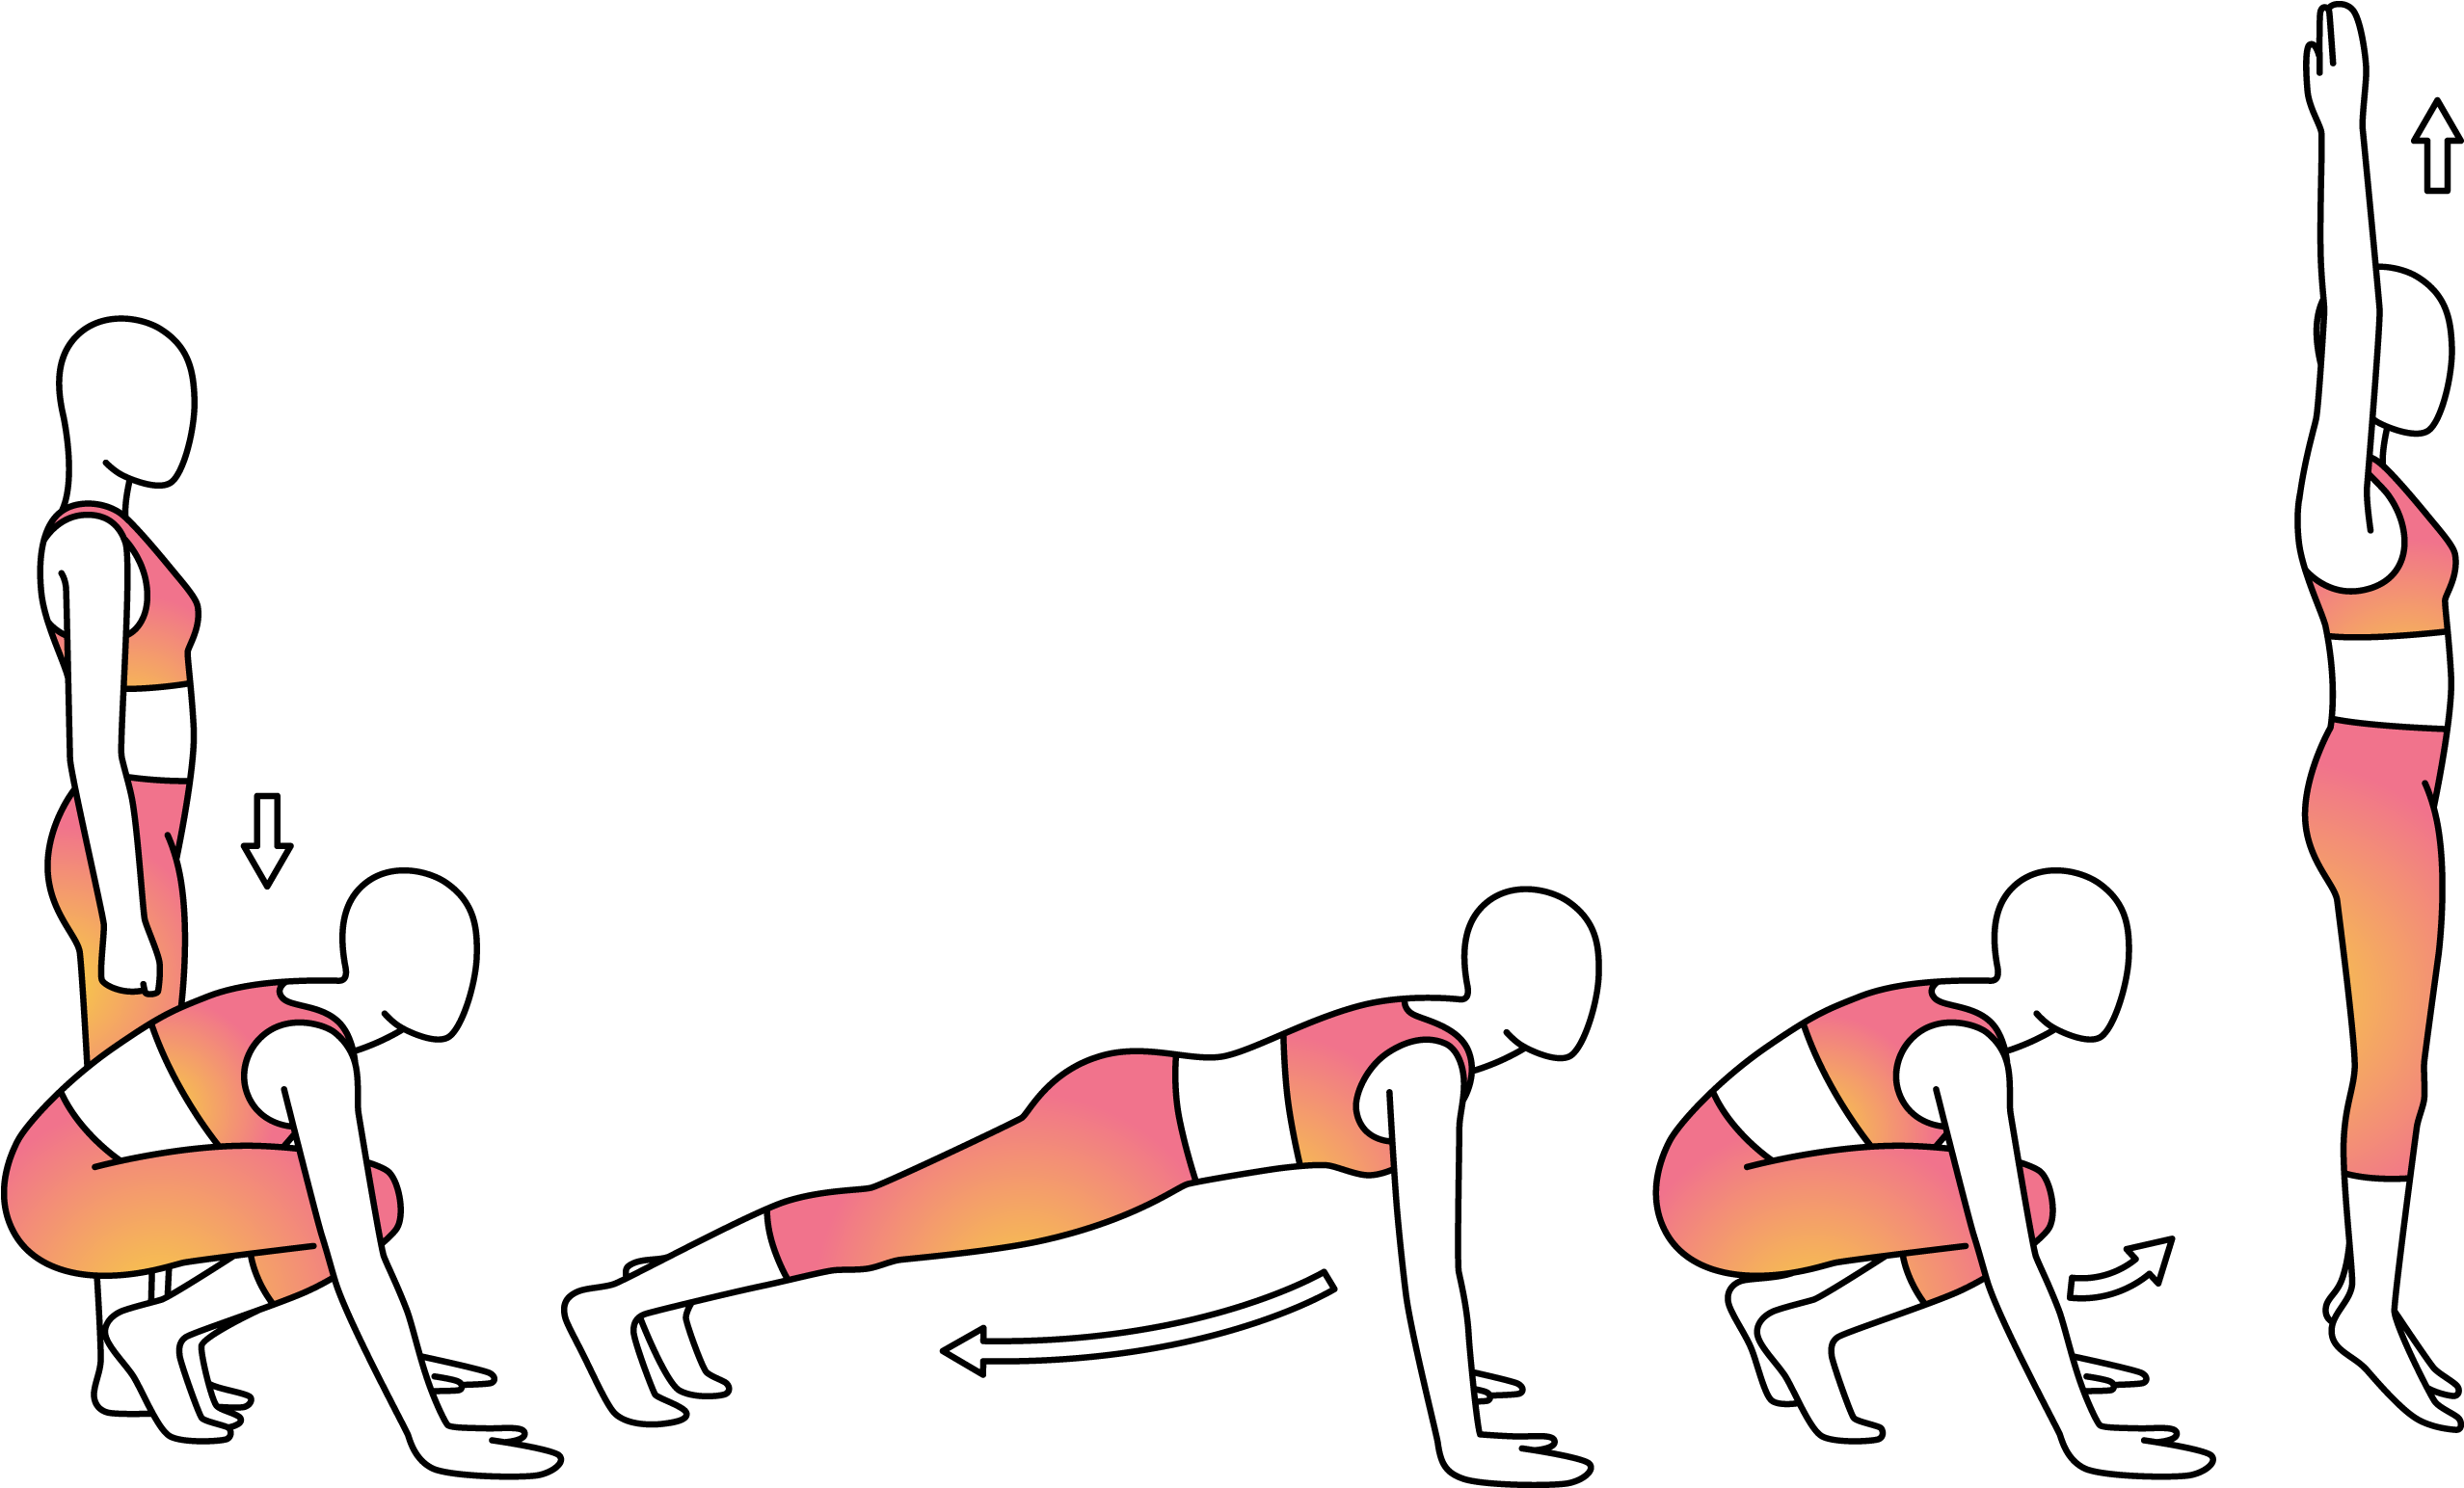](https://www.google.co.uk/url?sa=i&url=https%3A%2F%2Fwww.pinclipart.com%2Fmaxpin%2FhTwbRx%2F&psig=AOvVaw2hiLnsfSgMAox61iUGXw9L&ust=1585257878538000&source=images&cd=vfe&ved=0CAIQjRxqFwoTCPjK4vfHtugCFQAAAAAdAAAAABAE)

These can be challenging so take your time. Stretch those legs!

Exercise 7 – Sit ups

[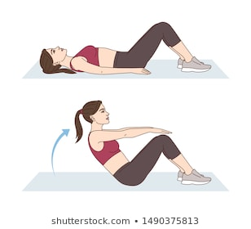](https://www.google.co.uk/url?sa=i&url=https%3A%2F%2Fwww.clipart.email%2Fclipart%2Fclipart-flexed-leg-sit-ups-384302.html&psig=AOvVaw0hHEaqugiKbA9nGwARmyS7&ust=1585258600762000&source=images&cd=vfe&ved=0CAIQjRxqFwoTCLiHl9DKtugCFQAAAAAdAAAAABAK)

Make sure your feet and knees are together. Don’t put hands behind head.

Exercise 6 – High knees

[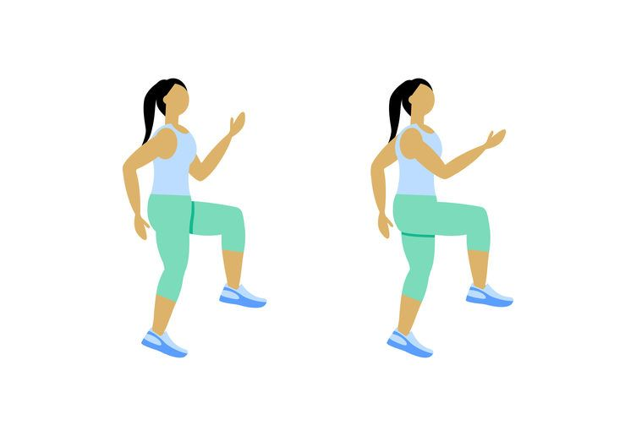](https://www.google.co.uk/url?sa=i&url=https%3A%2F%2Fwww.pinterest.com%2Fpin%2F748160556816959523%2F&psig=AOvVaw3JtFtHLx6-G4Ub70fuhHMb&ust=1585258369205000&source=images&cd=vfe&ved=0CAIQjRxqFwoTCMj23-HJtugCFQAAAAAdAAAAABAL)

Make sure you get your knees nice and high. Use your arms to help balance.

Exercise 8 – Squats

[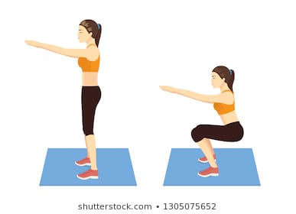](https://www.google.co.uk/url?sa=i&url=https%3A%2F%2Fwww.shutterstock.com%2Fsearch%2Fgirl%2Bsquat%3Fsection%3D1%26searchterm%3Dmotivational%2520bodybuilding%2520images%26measurement%3Dpx%26sort%3Dpopular%26image_type%3Dvector%26safe%3Dtrue%26search_source%3Dbase_related_searches%26saveFiltersLink%3Dtrue%26ref_context%3Dkeyword&psig=AOvVaw1YkkY964WD2S10y5TOA38G&ust=1585258851030000&source=images&cd=vfe&ved=0CAIQjRxqFwoTCOCUvMfLtugCFQAAAAAdAAAAABAS)

Drop down to seating position. Hold for 5 seconds.

Exercise 9 – Lunges

[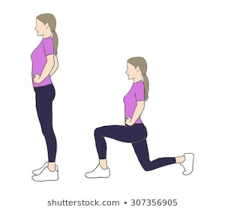](https://www.google.co.uk/url?sa=i&url=https%3A%2F%2Fwww.shutterstock.com%2Fsearch%2Flunge%2Bexercise&psig=AOvVaw1fIA_rXLCDNimdXwYEeZne&ust=1585259260667000&source=images&cd=vfe&ved=0CAIQjRxqFwoTCIjP6IrNtugCFQAAAAAdAAAAABAE)

Make sure you knee does not touch the ground. Hold for 5 seconds.

Exercise 10 – Skipping

[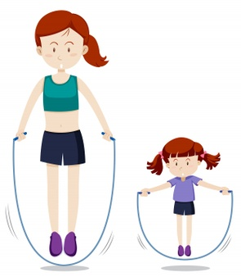](https://www.google.co.uk/url?sa=i&url=https%3A%2F%2Fwww.freepik.com%2Ffree-photos-vectors%2Fskipping&psig=AOvVaw3Q_nlEiD7IYJp7WL2bwU5s&ust=1585259579765000&source=images&cd=vfe&ved=0CAIQjRxqFwoTCKD9gqPOtugCFQAAAAAdAAAAABAO)

Make sure you jump as high as you can. A skipping rope isn’t necessary.