**Crazy cursive letters**

|  |
| --- |
| **Memory.Classic**  **untitled** |

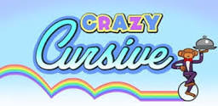

**Dinosaur/Spooky letters**

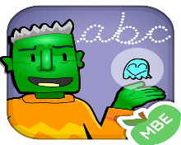

**Phonics Match**

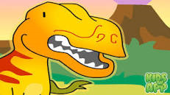

**Spell Mania**

