PPP

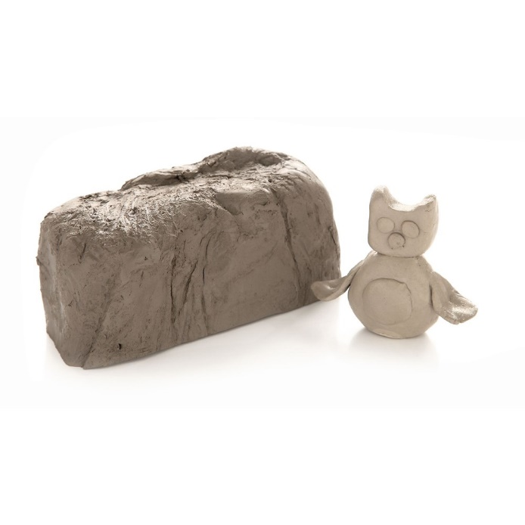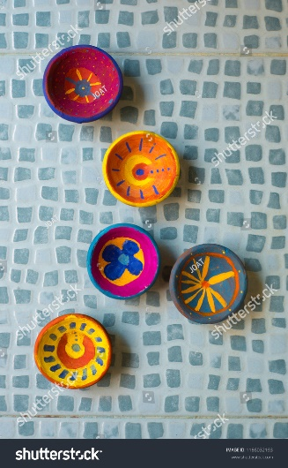

**You could use:**

playdough

<https://www.bbcgoodfood.com/howto/guide/playdough-recipe>

plasticine

paper clay

papier maché

air drying clay (Order online)

A

Air drying clay

**You could create:**

animals

leaf prints in clay

heart shapes using a cardboard stencil

shapes using biscuit cutters

**You could make:**

a thumb pot

a coil pot

use slabbing

use joins

Use