Motor Skills Activities

Gross Motor Skills Activities

Games using soft balls
Wheelbarrow races (using brothers or sisters, not real wheelbarrows!!) under supervision!
Bubbles
Badminton
Star jumps
Hoops
Doing the Hokey Cokey

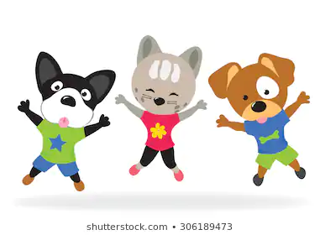

Fine Motor Skills

Any craft activity
Jenga
Dominoes (making queues with them and knocking down)
Dot to dots
Spot the difference
Tearing paper activities
Lego
Jigsaws

Perfect with some calming music on in the background.

