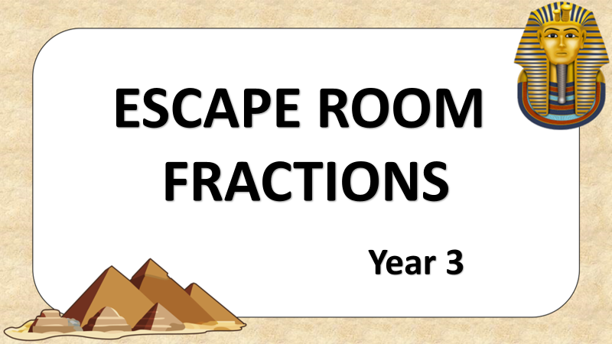

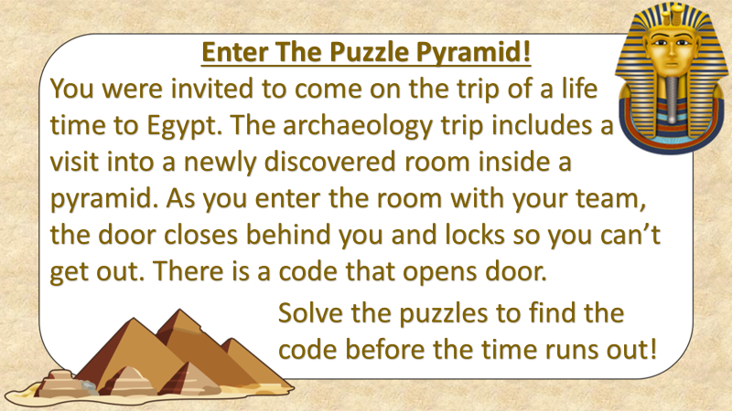

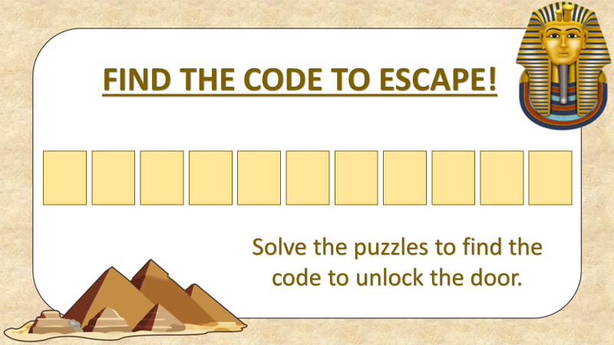

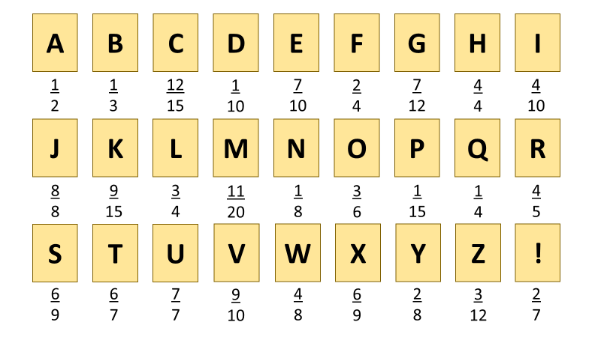

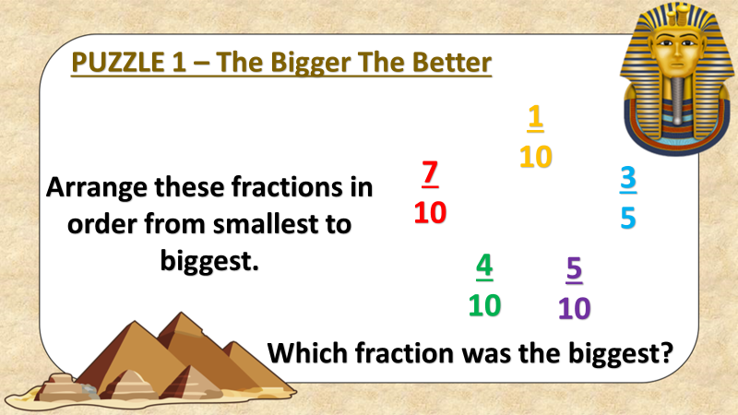

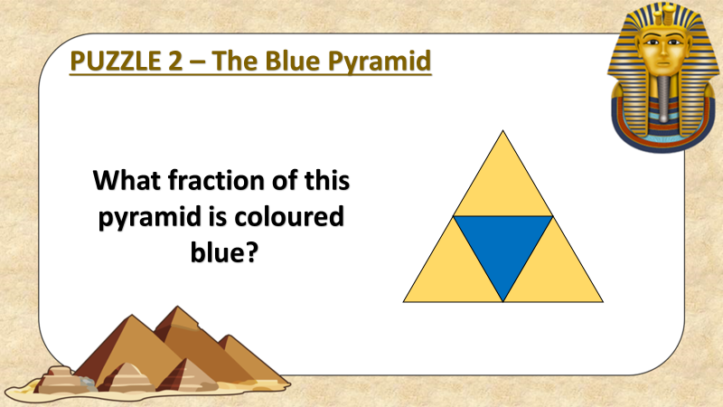

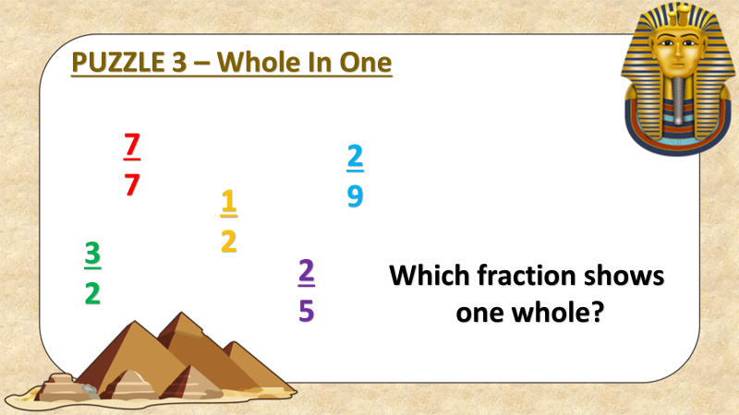

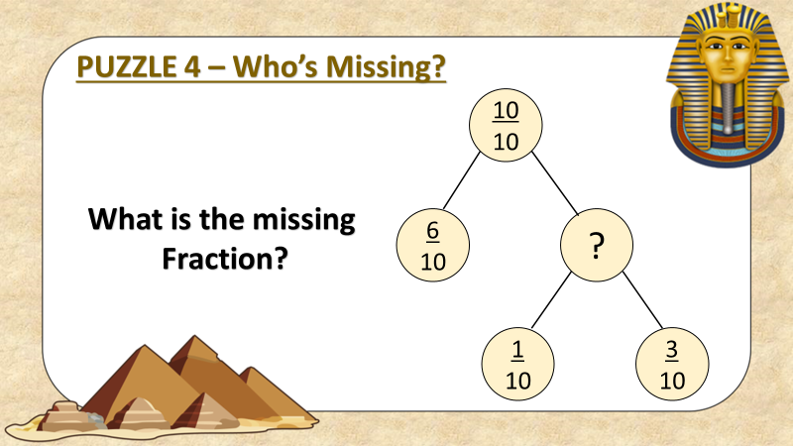

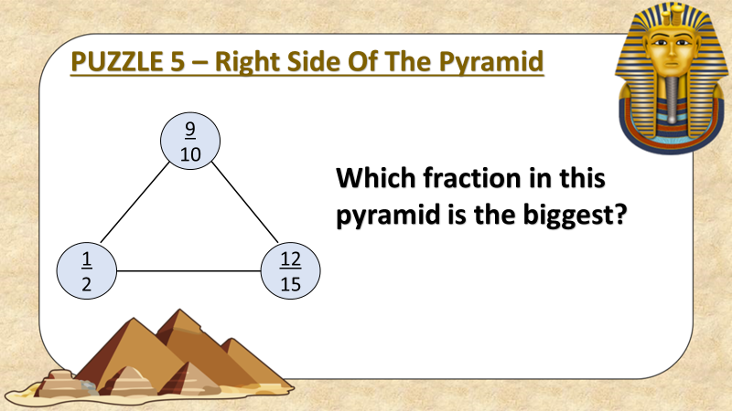

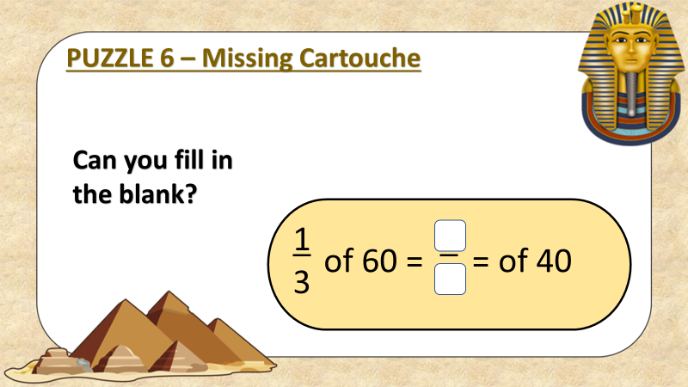

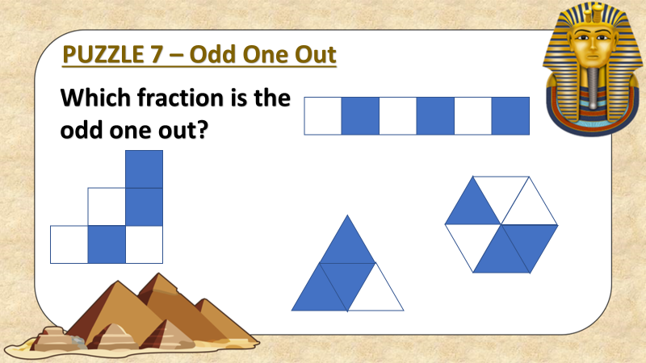

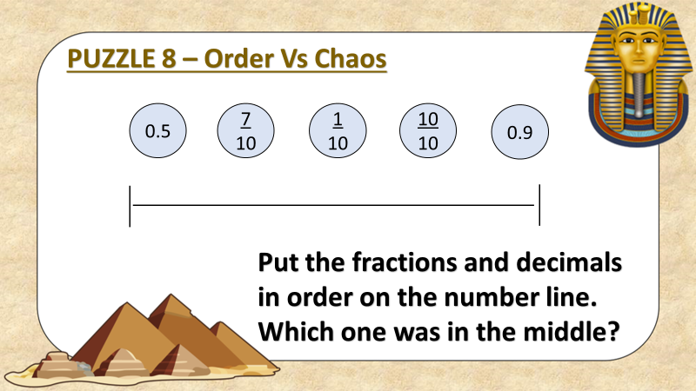

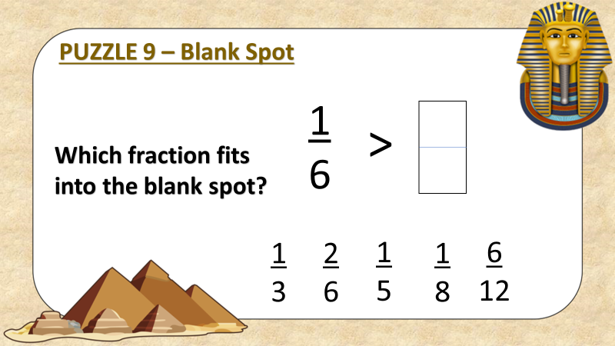

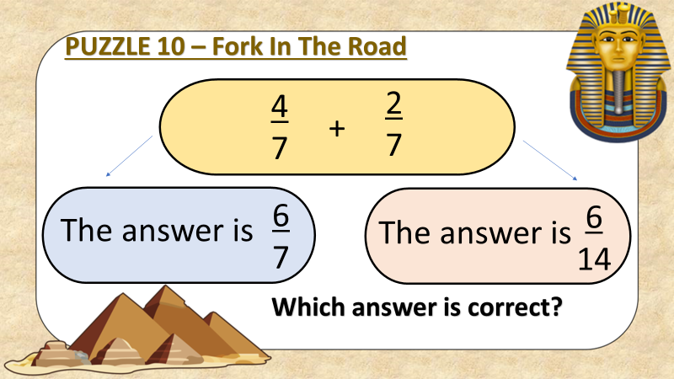

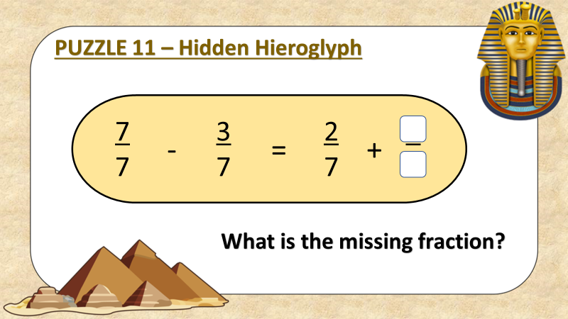

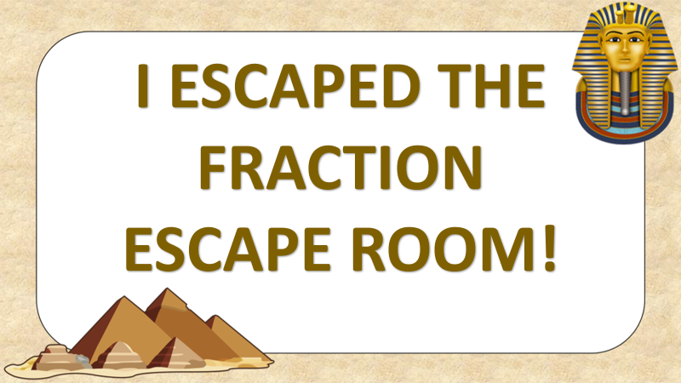

Escape Room: Fractions Y3
Puzzles | Answers | Code
PUZZLE 1 – The Bigger The Better,

PUZZLE 2 – The Blue Pyramid,

PUZZLE 3 – Whole In One,

PUZZLE 4 – Who’s Missing?,

PUZZLE 5 – Right Side Of The Pyramid,

PUZZLE 6 – Missing Cartouche,

PUZZLE 7 – Odd One Out,

PUZZLE 8 – Order Vs Chaos,

PUZZLE 9 – Blank Spot,

PUZZLE 10 – Fork In The Road,

PUZZLE 11 – Hidden Hieroglyph,

Fill in the Code!

