**6. Tourist Information Brochure**

You work for the tourist board and desperately need to encourage people to visit your region. Using all of the information you have gathered over the weeks about your specific region, you now need to produce a Tourist Information Brochure that includes maps, weather charts, key places to visit, leisure activities, a description of the main areas and a brief history of the place. Would I want to visit it after reading your brochure? You need to persuade me!

1. **Location, location, location**

Explain where your region is on a map of the Americas. Make sure you draw in the equator, northern hemisphere, southern hemisphere, identifying latitude and longitude.

Describe the location in terms of the world using geographical terms. Draw a separate map just of your specified region. Make sure you draw on and label the key physical features (mountains, flat lands, ice regions, rivers) On your map, locate major cities within your area. Can you explain the time zones of your area in relation to GMT (Greenwich meantime?)

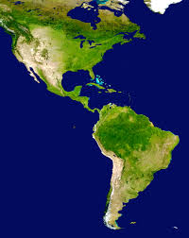

**4. Wonders**

What are the famous landmarks in your area? Are there famous buildings? Sports pitches? Are there any natural wonders? (Make sure you find out about the Seven Wonders of the World) Make sure you describe the location and include pictures/diagrams of your ‘wonders’.

**3. Human Geography**

Investigate the human side of your region. What is the population of your area? What cultures are evident? Where do people live? What types of accommodation do they live in (house styles)? What sort of work do the population do? (Towns and cities will mean office work, shops, schools, but prairies will mean farming is more popular) Are there any popular leisure activities related to your area (skiing, baseball, basketball, football, tennis?) Describe famous teams and famous people that have come from your area?

**5. History of your region**

Investigate significant historical periods in your region. Describe the main events that make this area famous (native Americas, famous civil wars, slavery, invasions)

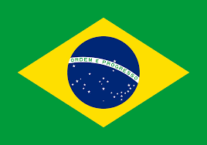



**2. Weather and Climate**

Research and describe the climate zones in your specified region. Does it have specific biomes and vegetation belts, rivers, mountains, volcanoes, earthquake zones?

Draw a chart to demonstrate the changes in temperature over the course of the year in your region. What is typical weather for this region? What affects this (mountains? rivers? forests?) What is affected by this weather pattern? (industry, farming, leisure activities?)