English Week 1
Hello Year 4,
I hope you are all ok and well. We are going to start our amazing, new English/Geography topic, Rainforests. I have set 5 different activities based on the first rainforest story we are reading. You can follow these activities as a baseline and take it as far as you would like. Stay inside, stay safe and enjoy
Our new story is called:
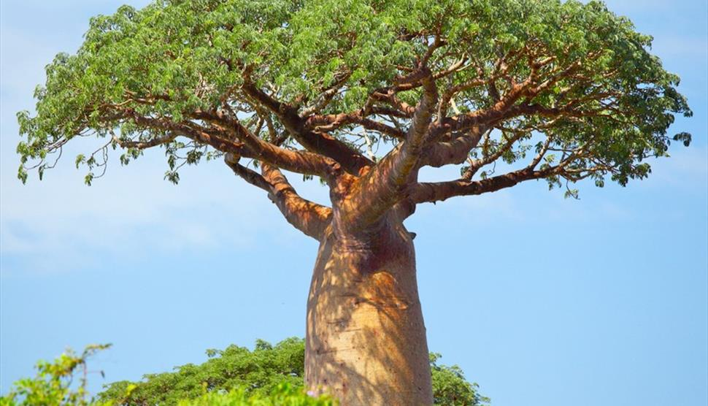
The Awongalema Tree

Day 1 (20/04/20):
Activity: Look at the picture and the title of the story we are reading. Create a mind map of predictions (an educated guess thinking about what will happen in the story) you think the story will be about and questions you want to ask about the story. (There is a worksheet available to print off if needed or draw on paper)
You will need: Sheet 1 (Questions and Predictions)
Prediction

I predict the story will be about a tree that can speak to other trees. It might go on an adventure to find other trees like itself.
Questions

Is the tree magical?
Can the tree talk?

Day 2 (21/04/20)
Activity: Read the story. Look for any features you can find in the story. (Think carefully about all of the language features we have already learnt about, for example, fronted adverbials.) Highlight these features and label. The features you find will form the Steps to Success for your writing.
Try to find some patterns in the story – Do animals arrive more than once? What do they all say?
Challenge: Can you answer any questions or edit your predictions now you have read the story?
You will need:
Worksheet 2 – Story
Day 3 (22/04/20)
Today, you are going to allow your imagination to run wild. You will be planning to write a story just like the Awongalema Tree. You will follow the same patterns and add in the same language features that are shown in the text. You may even want to add in some more language features.
However, there is a twist. You can make this story your own, by having your own magical object. This could be a treasure chest or a door to a room. You can also change your animals. For example, you may want to use a whale, goldfish, crab and a dolphin.
Task: Your task is to plan out your story using the ‘Box it up’ story plan. This will help you to understand what to write in each paragraph. Use the worksheet to help you.
You will need:
Worksheet 3 – Planning document
Worksheet 4 – Planning Lesson help sheet

Day 4 (23/04/20)
Today, you are going to use your plan to write your own version of the Awongalema Tree. It is important that you keep reading and checking your work to make sure it is in line with your plan. Think carefully, about all of the language features we have learnt in Year 4 and see how many you can use in the text. REMEMBER – Capital Letters and full stops!

Language Features in Year 4:
- Fronted Adverbials with a comma.
- Expanded Noun Phrases with preposition.
- Paragraphs
- Exciting Vocabulary
- Use of punctuation
- Use of speech – Use the help sheet if you have forgotten how to punctuate speech correctly.
You will need:
- A blank piece of paper
- Punctuating speech help sheet.
- Fronted Adverbial help sheet.

Day 5 (24/04/20)
Now it is your time to EDIT your writing. Remember you are the grammar police. Read through your writing and see how you can improve. Some thing you may want to consider:
- Have your written in paragraphs?
- Have you spelt everything correctly? (You could use Siri to help you check?)
- Have you used all of the language features in Year 4?
- Have you used capital letters and full stops?
- Can you improve on any of your vocabulary?

Now you have edited your stories, we cannot wait to read them! Email us at
year4@bankslane-jun.stockport.sch.uk

