1. **Your House**

Create a sketch map of your house. Use a key and symbols for the different rooms of your house. For example, the living room could have a symbol of a TV.

Which room is your favourite? Why is that your favourite? What is it mainly used for?

**6. Tourist Information Brochure**

You work for the tourist board and desperately need to encourage people to visit Offerton. You need to produce a Tourist Information Brochure that includes maps, weather charts, key places to visit, leisure activities, a description of the main areas and a brief history of the place. Would I want to visit it after reading your brochure? You need to persuade me!

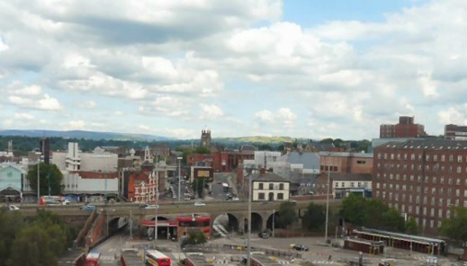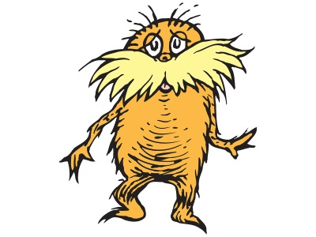

**2. What is around us?**

Use Google Maps to show children the area around your house. Switch between street, view, aerial view and map view to show the different features visible on each. What are the important landmarks near your house?

Draw a map to give directions to another location (e.g. from your house to school) and draw a simple sketch map of the route. Draw the distances between places using google maps?

**5. History of your region**

What did Stockport used to look like? Was it always a town? Were there any farms here? How has land use changed over time? Use the internet to investigate how we have changed Stockport over the years. Is it changing now? Think about Red Rock and a new tram to Manchester.

**4. Wonders**

What are the famous landmarks in Stockport? Are there famous buildings? Sports pitches? Are there any natural wonders? Make sure you describe the location and include pictures/diagrams of your ‘wonders’.

**3. Human Geography**

Investigate the human side of your town. What is the population of your area? Where do people live? What types of accommodation do they live in (house styles)? What sort of work do the population do? Are there any popular leisure activities related to your area (skiing, baseball, basketball, football, tennis?) Describe famous teams and famous people that have come from your area.