3rd November 2017
Dear All,
AUTUMN 2 NEWSLETTER
All the activities and lessons are now ‘ticking over’ well so I can begin to think about performances running up to Christmas. Here are some dates for your diary :-
Friday 3rd November – Regular classes after school :-
- Juniors 3.30 to 4.30pm.
- Junior Intermediates 4.30 to 5pm.
- Senior Intermediates 5pm to 5.45pm
- Top group of seniors 5.45pm to 6.30pm. NB Senior intermediates who are wanting to go to Cugand will need to stay until 6.30pm so as to rehearse with the ‘top group’.
Saturday 4th November – Headstart. Mrs.Fosbrook in to give extra theory tuition.
Friday 10th November – Usual classes until 5pm. 5pm onwards will be a rehearsal for the performance at Marple Old Folks’ Hall. This will last until 5.45pm. There will be a class for seniors who are going to Cugand from 5.45pm to 6.30pm.
Saturday 11th November - Headstart. There will be a rehearsal for Marple during the morning as well as the regular classes. People going to Marple will need to bring costumes and lunch. They will be excused from singing to have an early lunch so that we can set off at 1.15pm. Please organise lifts for this event and offer some if you can as there will, no doubt, be people with no transport.
Friday 17th November – Usual classes until 5.45pm. Possible rapper workshop for girls. tbd.
Saturday 18th November – Headstart. Possible rapper workshop in afternoon. tbd.
Friday 24th November – Normal rehearsals until 5pm. Then it will be a rehearsal for the group going to ‘New Mills Lights Switch On’ from 5pm to 5.45pm.
Saturday 25th November – Headstart. This will include an extra rehearsal for ‘New Mills Lights Switch on’. This will be an early evening event so there will be time to go home to get changed. I am expecting that we will perform a couple of times but have requested that it is before 7.30pm as one of the group have to leave at this time for another gig. Please organise lifts as soon as possible.
Friday 1st December – It is our school fair and we have been asked to perform twice. The junior choir will do a spot at 3.45pm and the massed Fosbrooks will do one at 4.30pm. I am hoping that there will be enough top seniors to do a small performance featuring them after the massed performance.
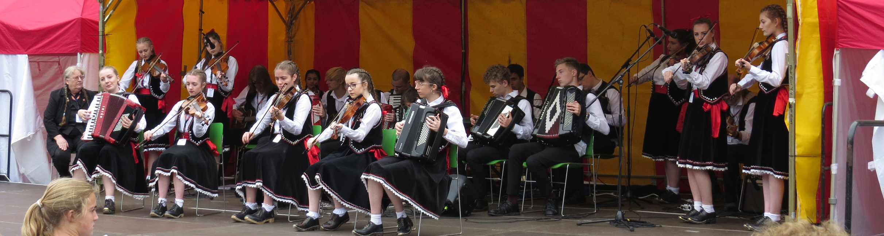
Senior group at Alnwick Folk Festival, Northumberland.

Saturday 2nd December – Headstart as usual.
Friday 8th December – Normal rehearsal until 5pm only. The top group are performing at Bury Met with the Demon Barbers so we will be setting off at around 5pm for this event. I AM BOOKING THE TICKETS FOR THIS TONIGHT SO PLEASE CONFIRM WHAT YOU NEED FOR THIS.
Saturday 9th December – Headstart.
Tuesday 12th December – Junior performance at Saint Mary’s in the Market.
Friday 15th December – Rehearsals for Christmas Show.
Saturday 16th December – Rehearsals for Christmas Show during Headstart time. The Christmas show will be in the early evening.
There will be a separate letter about the Christmas events.
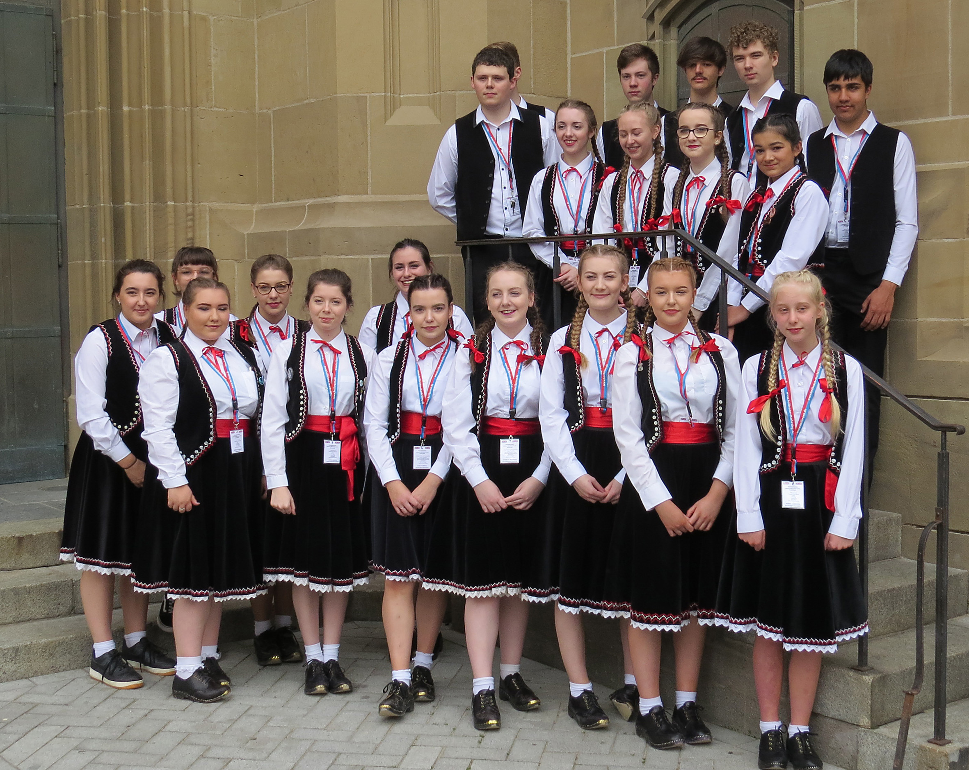
Senior team in Helbronn, Germany in June.
Missed classes. If anyone has missed a class due to their teacher being off, this will be made up. Mr. Schofield has missed some this week but will endeavour to get these ‘caught up’ over the next fortnight.
Seniors, please make every effort to pay your Autumn 1 subs and tuition if you haven't already done so as it is due out again soon.
Liza

