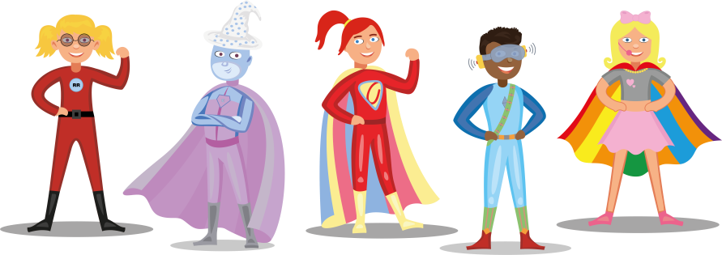

**What makes me happy:**

_________________________________________________________________________________________________________________________________________________________________________________________________________________

**A picture of me:**

**The things people love about me:**

______________________________________________________________________________________________________________________________________________________________________________________________________________________________________________________________________________

Please complete this sheet with your parents. Feel free to write or draw labelled pictures – we’d love to find out all about you! Please bring it with you to give to your new teacher when you start.

**Name:**

**___________________________**

**The people who are important to me:**

_________________________________________________________________________________________________________________________________________________________________________________________________________________

**How I like to be supported:**

_________________________________________________________________________________________________________________________________________________________________________________________________________________